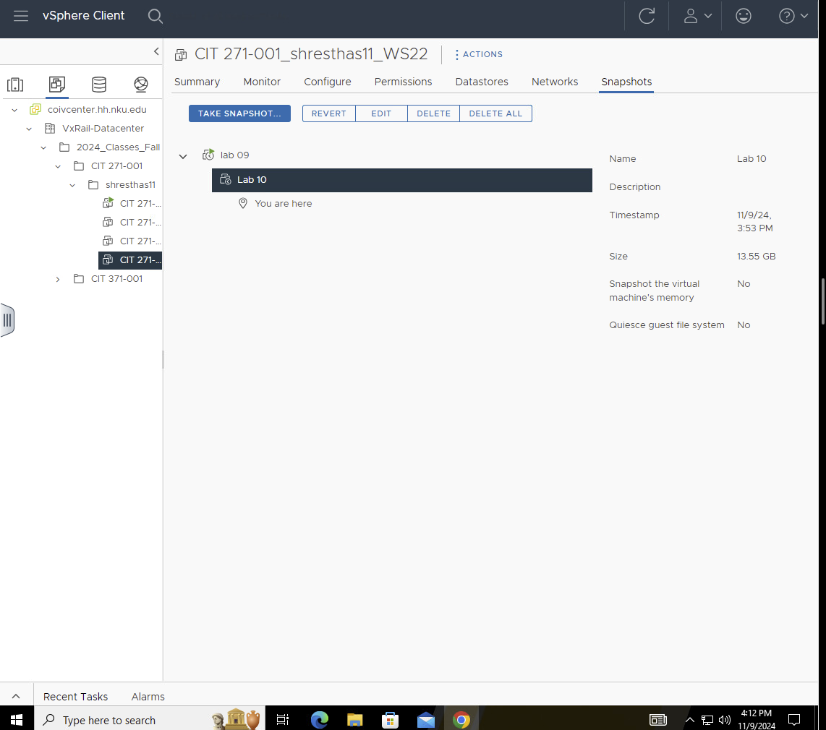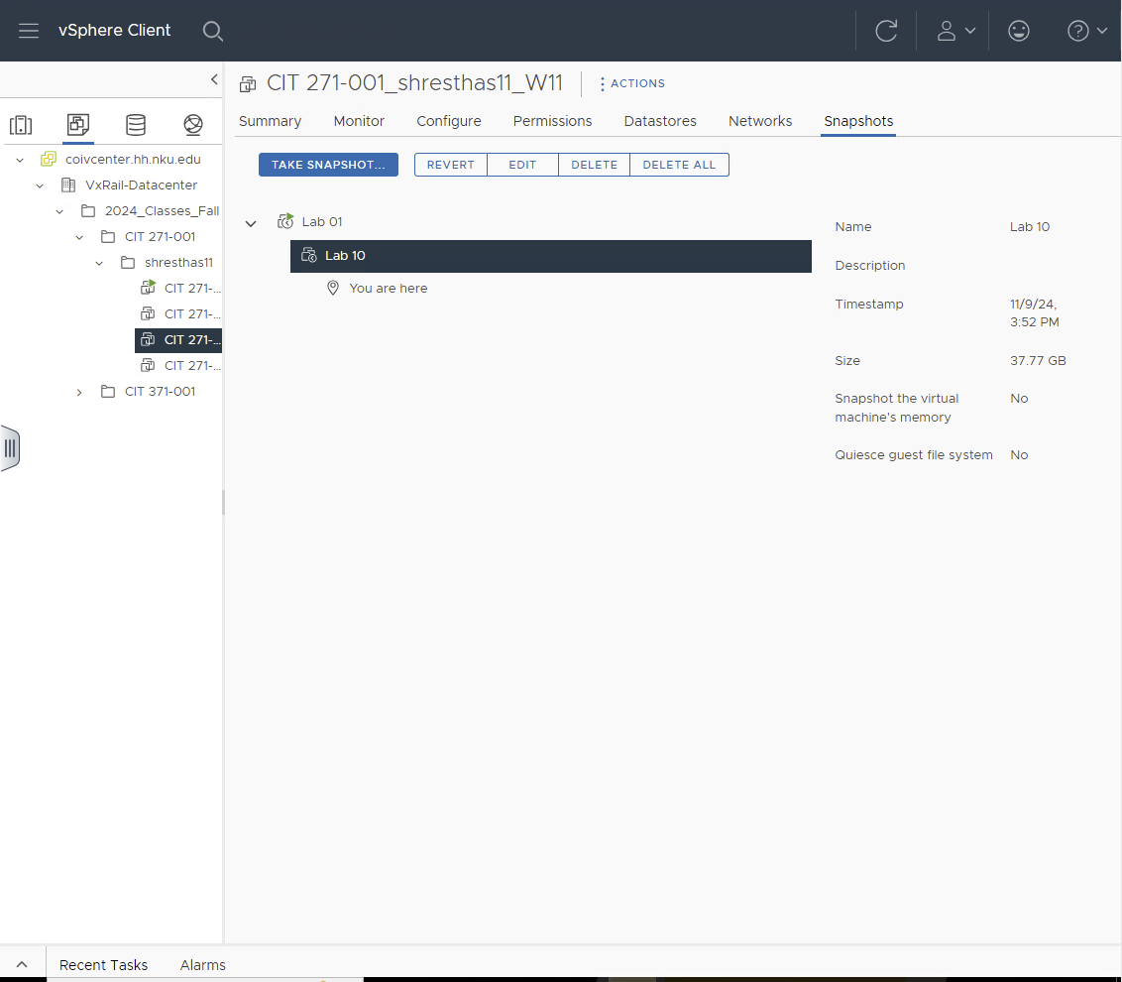

Deny log on locally: Computer Configuration > Policies > Windows Settings > Security Settings > Local Policies > User Rights Assignment
Login title: Computer Configuration > Policies > Windows Settings > Security Settings > Local Policies > Security Options > Interactive logon: Message title
Login message: Computer Configuration > Policies > Windows Settings > Security Settings > Local Policies > Security Options > Interactive logon: Message text

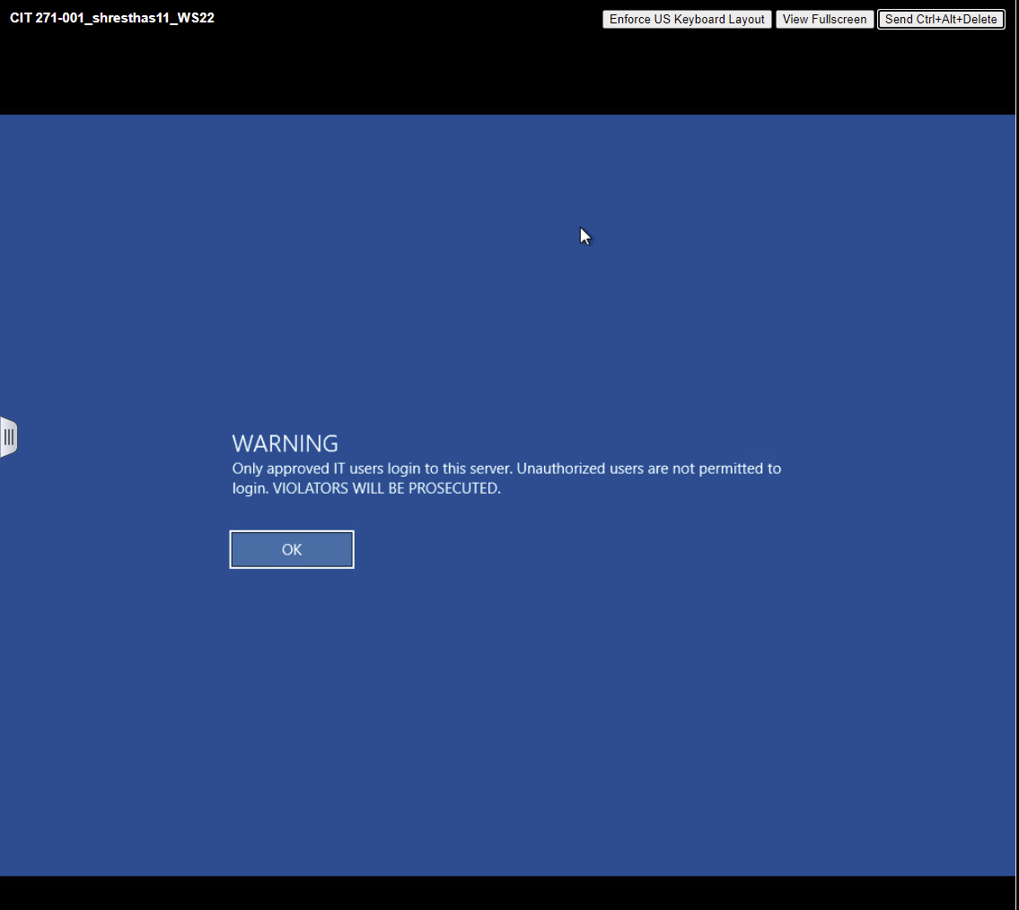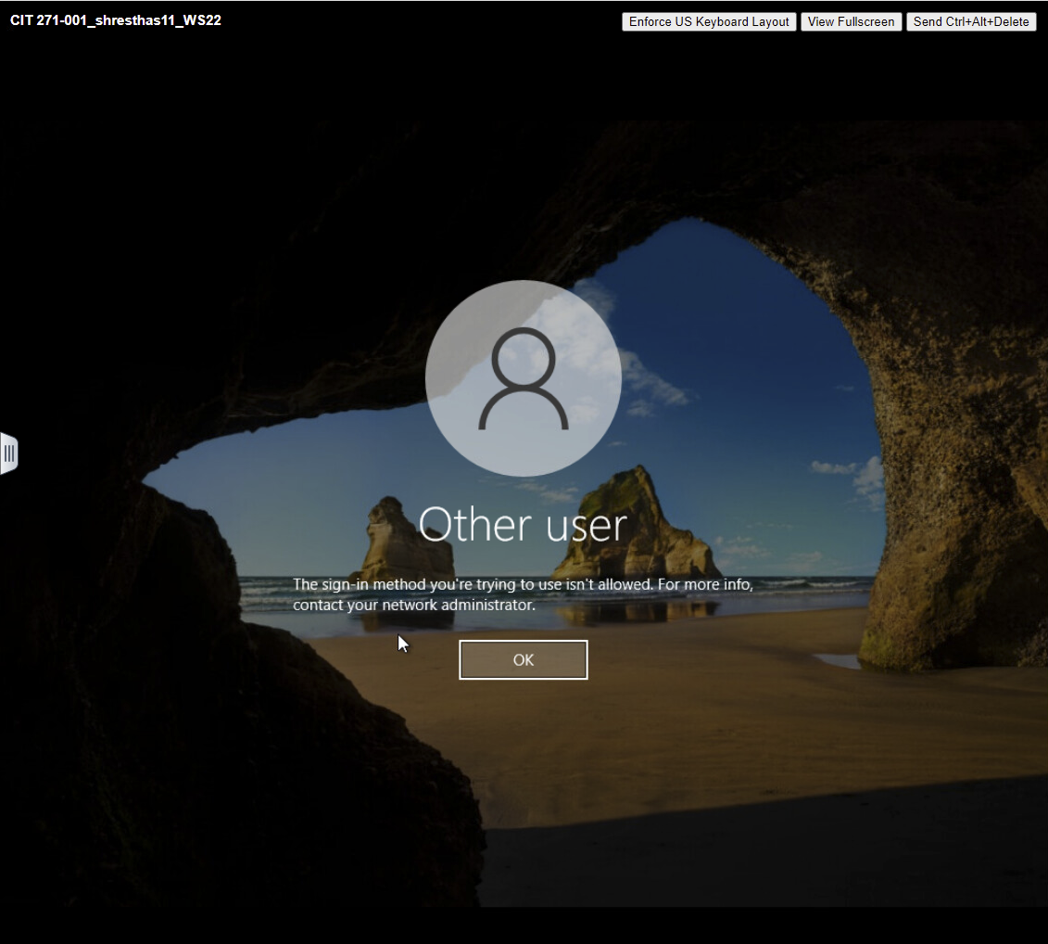

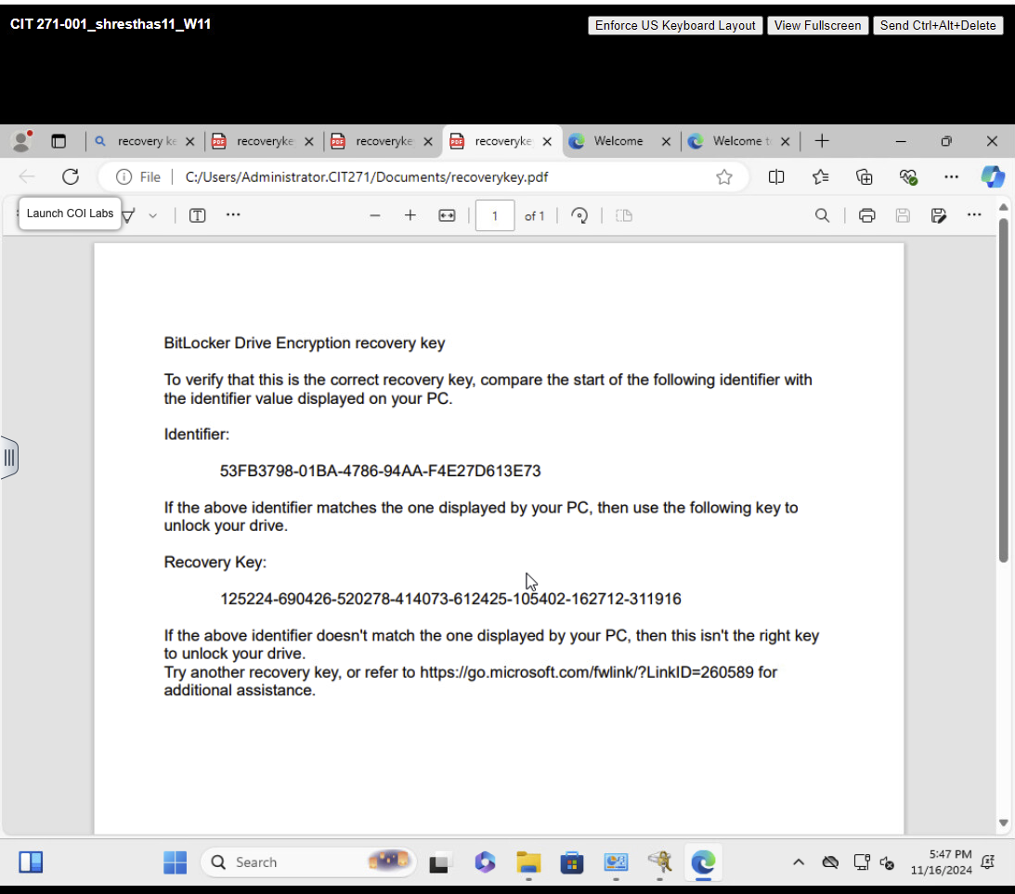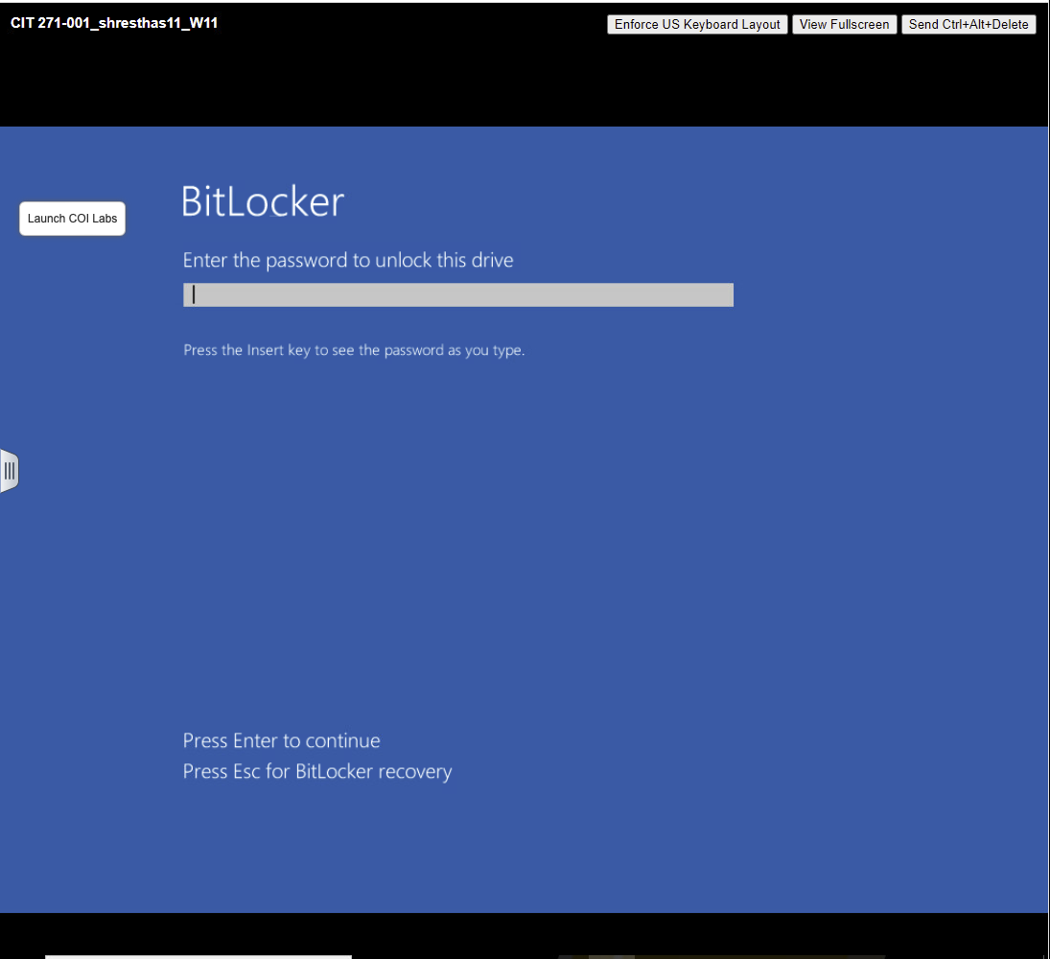

Command Prompt: User Configuration > Policies >Administrative Templates > System > Prevent access to the command prompt
Registry Editor: User Configuration > Policies >Administrative Templates > System > Prevent access to registry editing tools

